Audio Engineering (The Sounds of Science)
A Review of the Discourse Community
Roman Salas
Pasadena City College

Author Note
This paper was prepared for English 1a taught by Professor Ogden

Abstract
The purpose of this research paper is to identify the importance of the discourse community of audio engineering. Building a foundation on the knowledge that is known this research paper will examine the profile of an audio engineer to further the readers understanding and give new definition to the title audio engineer. Looking deeper into the discourse community the problems that plague audio engineers are viewed and discussed by scholars and professional audio engineers. The problems discuss range from the role women play in the audio engineering community and examining working in a male dominated field to the advancements in technology that has increased the popularity of recording at home and what effects it has on the discourse community of audio engineering. Through my own research and studies the examination of each problem is observed and understood by figures, facts and data gathered. Solutions to these problems are suggested. These solutions offer resolution and help better the discourse community of audio engineering. This research paper shows the significances of the role audio engineering plays in the discourse community and intends to inspire both people outside and inside the discourse community of audio engineering to change the way they think of audio engineers.

Audio Engineering (The Sounds of Science)
I Being a part of a larger discourse community I will focus on the importance and job of an audio engineer and showcase the process in which one must go thought and the contributions one adds to this discourse community.
A. The Handbook of Recording Engineering by John Eargle defines an audio engineer as “An engineer in sound who is responsible for the recording, manipulation, mixing and reproduction of sound”
B. Having multiple responsibilities the job of and audio engineer is a very important part when recording any production with sound.
C. The work of an audio engineer can have a huge impact on someone. When listening to any song or movie the audio plays an important part and it is up to the audio engineer to make that perfect.
II “A discourse community" is a group of individuals bound by a common interest who communicate with through approved channels and whose discourse is ensure what’s best for said Discourse Community” (Intertextuality and The Discourse Community pg 39).
A. James Porter, a Professor in the Department of English and Armstrong Institute for Interactive Media Studies at Indiana University mentions that these people involved in the discourse community should have common interest and usually has to go through different channels in order to direct the discourse community in a certain direction for change.
B. This quote is used in the essay to explain not only what a discourse community is but to also show how it is related to the specific one the reader is reading about, audio engineering.
C. Just like all discourse communities audio engineering has its own goals and lexicons that one must know in order to become apart of.
III. "Here in the future, musicians and record companies complain they can't make a living any more. The problem isn't piracy — it's competition. There is too much music and too many musicians, and the amateurs are often good enough for the public. This is healthy for culture, not so much for aesthetics, and terrible for musicians. You can do better with a proper engineer in a proper studio, but you don’t have to. And whenever quality competes with convenience, convenience wins every time. You can protest that your music is a finely-prepared steak cooked by sheer genius, and be quite correct in this, and you have trouble paying for your kitchen, your restaurant, your cow."
A. David Gerard a professional Sound Engineer for Record Plant Studios shares his views of the future of audio engineering and the differences between professional audio engineers sound quality and amateur audio engineers and the sound quality.
B. This quote is used to show a number of things in the essay. The advancement of technology in the field of audio engineering that has brought both pros and cons with it and consequences that have come out of its benefits.
C. This shows in the essay that because the general view people hold on sound is being created by so many amateurs that this is what the future of music will sound like. I feel that this quote is what best represents the struggle happening right now in the audio engineering discourse community.
Conclusion:
A. The career of an Audio engineer is a great one to have. It is great to help others with the passion and help bring that passion out of them. Helping the artist realize the dream and being a part of the creative process is a rewarding experience. From being responsible for the recording and mixing to helping shape the sound, this is the audio engineers job and own reward.

When listening to a song for the first time we may first notice the beat of the drums, the depth of the bass line, the unique sound of the vocals, or even the overall feel of the whole song in general. Most people will then praise the artist for his creative genius, but let’s not be too hasty; that is only one of the ingredients to making a great song. Before the song is released for the public’s pleasure, it must first be created in the studio and that is where the audio engineer comes in. The Handbook of Recording Engineering by Eargle J defines an audio engineer as “An engineer in sound responsible for the recording, manipulation, mixing and reproduction of sound” (p 6). This definition best captures the importance and responsibility of the audio engineer to his discourse community. In order to truly understand the value of the audio engineer a look into the profile is important. Being a part of a larger discourse community I will focus on the importance and job of an audio engineer and showcase the process in which one must go thought and the contributions one adds to this discourse community.

Before demonstrating the importance of an audio engineer to his discourse community lets first define what a discourse community is. Porter J, a Professor in the Department of English and Armstrong Institute for Interactive Media Studies at Indiana University states “A discourse community" is a group of individuals bound by a common interest who communicate with through approved channels and whose discourse is ensure what’s best for said Discourse Community” (Intertextuality and The Discourse Community p 39). Porter mentions that people involved in this discourse community should have common interest and usually have to go through different channels in order to direct the discourse community in a certain direction for change. Just like all discourse communities audio engineering has its own goals and channels that one must know in order to become apart of the discourse community. Upon this foundation of knowledge I will further ones understanding of the importance of audio engineering by remarking on the history of how this discourse community came to be.
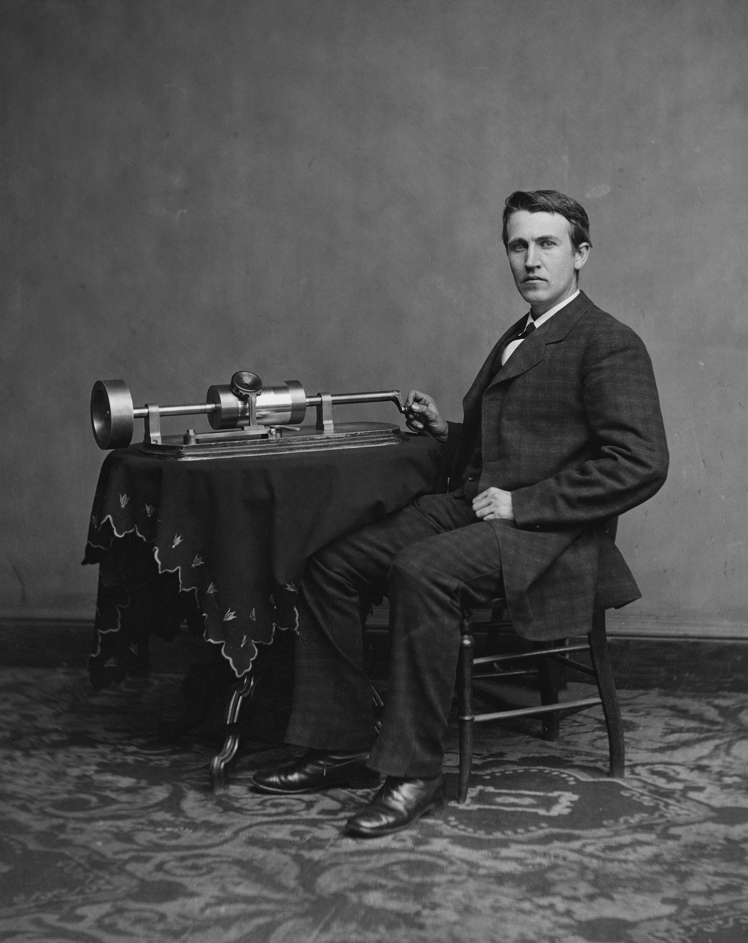
Thomas Edison
How Audio Engineers Came About
Rewind over a century ago to the year 1877 Thomas Alva Edison has successfully recorded his own voice singing Mary had a little lamb from a strip of tinfoil wrapped around a spinning cylinder hence the birth of the record. Four years later stereo recording is accidently invented by Celment Ader who when using carbon microphones and an armature set of headphones which produced a stereo effect to monitors adjacent to him. Many years later the recording industry advancements have now made it possible for artists to record a cleaner sound and with the ability to mass produce records it become a very successful business. From the days of two track recording to four track recording and eventually eight track recording we now have the ability today to record unlimited tracks with the use of computer interfacing. The modern technology we use today to record can now be done at home and is making it a lot easier for people who may be interested in audio engineering to become more informed and involved.
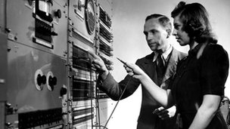
Audio Engineer In Training
Entering The World of Audio Engineering
Prospective Audio Engineers might go to a special trade school specializing in audio engineering while another person could get a degree in the science of sound engineering on a more technical level depending on what part of audio engineering they wish to be in. Because of the modern technology we have today, the other alternative would be to simply buy the equipment and with tutorials online and unlimited research, figure out just how to do everything an audio engineer does. This is not to say that there is one way that is better then the other way, all ways have merits. Kennedy R a sound engineer for Warner Brothers Studios got involved by learning through first-hand experience and getting an apprenticeship in a studio. He ensured me that this way of learning for him was perfect and lucky because he knows that most places these days wish for new audio engineers to have prior experience. Learning and listening to Ryan Kennedy demonstrates that just like most jobs today that knowledge is key and will open the door to success. Another way of getting involved in this field would be by a trade school. These trade schools have become increasingly popular and offer a great way of learning the trade by focusing on nothing but audio engineering. Today the discourse community of audio engineering has become a lot easier for anyone to become apart of.
Credits And Self Recognition
Behind the scenes you don’t always get the credit you deserve most the time satisfaction has to come within. Porter J writes “When we romanticize composition by overemphasizing the autonomy of the writer, important questions are over looked, the same questions an intertextuality view of writing would provoke: To what extent is the writer's product itself a part of a larger community writing process? How does the discourse community influence writers and readers within it? These are essential questions, but are perhaps outside the prevailing episteme of composition pedagogy, which presupposes the autonomous status of the writer as independent cogito. (Intertextuality and The Discourse Community p 42).” Examining this view connections can be made between the writer and his discourse community with the discourse community of the audio engineer. When we idolize the work of others by putting them on a pedestal we tend to not see the work for what it really is and tend to not view the people that may of helped them get there. Geoff Emerick The Beatles audio engineer credited for helping make one of the most important albums in history didn’t receive any credit at all. Emerick who writes in his book “Here, There, and Everywhere” “Although not getting any credit hurt I didn’t let it stop me from continuing the job I loved” (Pg 189). Emerick is also credited for making “The Beatle Sound” with the uses of nontraditional methods such as damping the drums with a sweater to using ribbon microphones as dynamic microphones to get a warmer sound out of the amps. Both these ideas were revolutionary at the time but again the credit is autonomous and is looked at as common practice for all audio engineers today.
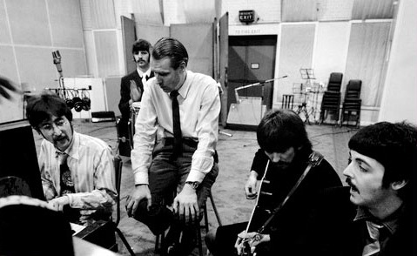
Geoff Emerick And The Beatles In Studio B At Abbey Road
The career of an Audio engineer is a great one to have. Although you might not always get the credit you deserve it is great to help others with the passion and help bring that passion out of them. Helping the artist realize the dream and being a part of the creative process is a rewarding experience. From being responsible for the recording and mixing to helping shape the sound, this is the audio engineers job and own reward.
Definition Of An Audio Engineer
The audio engineer plays a significant part of his discourse community by linking together the creativity of the artist with the science of capturing and sculpting sound. This may involve but is not limited to recording, manipulating, mixing or the reproducing of sound. The Webster’s encyclopedia definition of an audio engineer as “A person whose career is concerned with the recording, management, mixing and replication of audio sound”. This being stated we could go even further in understanding the contributions of an audio engineer and his role in his discourse community. I will demonstrate what it means to be an audio engineer and showcase key concepts to better one’s understanding of this field of work.
When looking at the word audio engineer we can take it apart and focus on the two words that make it up, audio and engineer. The word audio pertains to the high-fidelity sound that makes up an audible sound. In the book “Understanding Audio” by Thompson D these frequencies can be anywhere from the human range of hearing which is as low as 12 Hz (hertz) under ideal laboratory conditions, to as high as 20 kHz (Kilo-hertz) and anywhere above or below that. We now look at word Engineer that means a professional specialist of engineering, concerned with applying scientific knowledge, mathematics, and inventiveness to develop solutions for technical problems. Together these words make up an understanding of the specialty of an audio engineering.
The common understanding of the word audio engineer is a term used to identify the person in a music-recording studio whose job it is to record performances of music on tape or computer hard disk. With todays advancements in technology we can have the opportunity to learn and record ones own musical performances in the comfort of ones own home. This definition of the common understanding of audio engineer means now that anyone can call himself or herself an audio engineer. By this standard the term is now used loosely. Well being beneficial there are some drawbacks. Artist who usually do the own home recordings often are at a disadvantage due to the fact that a lot of the studio work is done “In the box” (Within the computer) with the gear being inexpensive and only partially up to par. The advantage to professional audio engineering is the use of “Top Shelf” equipment and the talents of someone who is an expert in the field. Both ways of recording are acceptable but there are some people who would argue against one over the other. Gerard D a professional Sound Engineer for Record Plant Studios says
"Here in the future, musicians and record companies complain they can't make a living any more. The problem isn't piracy — it's competition. There is too much music and too many musicians, and the amateurs are often good enough for the public. This is healthy for culture, not so much for aesthetics, and terrible for musicians. You can do better with a proper engineer in a proper studio, but you don’t have to. And whenever quality competes with convenience, convenience wins every time. You can protest that your music is a finely-prepared steak cooked by sheer genius, and be quite correct in this, and you have trouble paying for your kitchen, your restaurant, your cow." (http://rocknerd.co.uk/2013/09/13/culture-is-not-about-aesthetics-punk-rock-is-now-enforced-by-law/) Gerard’s views of the future of audio engineering and the differences between professional audio engineers sound quality and amateur audio engineers sound quality reveals that the advancement of technology in the field of audio engineering has brought both pros and cons with it and that the consequences that have come out of its benefits are too take in consideration. Gerard believes that anytime a person has to choose quality or convenience that convenience will always win. So many amateurs are creating the general view people hold on sound today that this is what the future of music will sound like. Although a struggle the work of a true audio engineer can only be graded by the work he has to show and with that work also comes the personal touch one adds with the own ears and ideas.
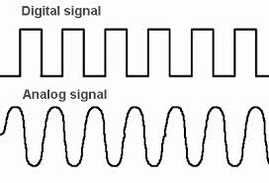
Analog VS Digital
Audio Engineering can be looked at though different points of view. These points of view usually can be divided by ones preferences in the recording process, from the technical side like microphone placement or types of reverb to use to the over all use of the benefits of Analog recording versus Digital Recording. A person can argue that true audio engineers are masters in the analog side of recording and that it gives the audio being recorded a warmer sound well the other side may say that digital recording is the way of the future and makes it a lot easier for the audio engineer to mix and manage tracks. Two musicians that have different approaches when recording are Jack White from the White stripes and The Edge from U2. In the Documentary “It Might Get Loud” both musicians demonstrate the attitude with recording and discuses together what they benefit from the chosen process. Again both ways have the pros and cons but should not be looked at as the judge of what makes an audio engineer great. Both skills should be looked at as one whole and be taught and incorporated together.
The many roles of an audio engineer are very important in every performance. Whether they are tracking audio at home with a microphone place next to the amplifier or nside a big studio hooking up the condenser microphones and checking the VU(Volume unit) meters and the EQ(Equalization) to make sure the artist will sounds great. All these practices together with the knowledge of sound are what make for an audio engineer. It is only with the personal touch and original ideas that we can distinguish great audio engineers.
The Problems In The Audio Engineering Community
Over the years the discourse community of audio engineering has advance from the early days of Thomas Edison and his recorded cylinder to the use of major studios and the reliance on audio engineers for the knowledge and skills of sound. With these advancement in audio engineering also comes difficulties and problems. These problems ranges from the diversity of the ratio of men and women in the field, to the ability to engineer from home and have unlimited options on what to record, to even the many trade schools that offers courses in audio engineering that creates high competition for jobs in this field. The major problem of this discourse community is making the general public aware that the quality of audio matters and that we should not forget that there is a science behind the audio.
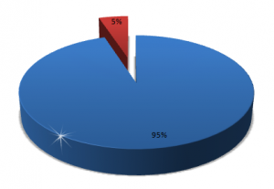
Pie Chart of Men To Women In The Field Of Audio Engineering
The work of audio engineering has for the most part been a male dominated career choice. An article in the BBC news written by Savage M discuses how when looking at the field of Audio engineering that it is 95% male (http://www.bbc.com/news/entertainment-arts-19284058). Well being a male dominated career that is not to say that there are women that were able to break this barrier in the audio engineering world. Sylvia Robinson CEO and founder of Sugarhill record label was also responsible for the famous hip-hop classic Rapper's Delight which she produce and engineered. Another woman who became the variable in the world of Audio engineering was Shoemaker T. BBC news interview Shoemaker on what it was that drew her into Audio engineering saying, "I didn't actually care about the musicians, I cared about how it happened. Why did it come out of the speakers like that? Why does the needle go into that groove and make music come out of those cones? And who does that?" This spark of curiosity help drive Trina Shoemaker to become the first woman to win a Grammy for Audio Engineering. Though there still is more males in the industry of Audio engineering there are the few women that help become the example and show women that there is opportunity in this field for women.
The advancement of audio engineering has change over the years. From the old days of big studios, giant rigs of compressors and equalizers and sound boards that have as much as 8 to 64 tracks to record an album. We now have the ability to create our own studio in the comfort of our own home. The progress of computers has made a huge impact on the way we record albums today. This technology allows us now have unlimited tracks to record and even allows us to compress the size of our gear we use with now having the option of using the many recording programs offered when recording digitally. With having so many options to record many audio engineers are now face with the endless amount of possibilities that artist might want to take and having to deal with the indecisiveness of the artist. Iyengar S a Phys-economist argues that well having choices are good it is best when trying to decide on a choice that we have fewer options oppose to unlimited. (http://www.ted.com/talks/sheena_iyengar_choosing_what_to_choose)
People are far more likely to pick an option faster and be more decisive when dealing with fewer choices. This model of thinking helps us see problems that plagues audio engineers today.
Audio engineering has become a more and more popular career choice. There have been many schools developing programs dedicated to the craft of audio engineering and even offer hands on internships at some of the more major studios. Trade schools have also picked up on the popularity of audio engineering and have open up special school focusing on teaching audio engineering. Well both colleges and trade schools offering courses in audio engineering they have created high competition for jobs in this field of work. The job market has also become smaller for audio engineers looking for work because of the convenience of home recording. With all these options of recording and the conveniences of doing it yourself many studios have cut back on hiring Audio engineers well other studios have went under all together. Olivarez-Giles N writer for the Los Angeles Times writes in his article; Recording Studios are being left out of the mix “Inexpensive software is shifting music-recording to the home. Industry experts estimate that up to half of the commercial studios in the L.A. area have closed or been sold to artists for private use.” ”(http://articles.latimes.com/2009/oct/13/business/fi-smallbiz-studios13) This isn’t only happening in Los Angeles other places like New York and Tennessee have also been hit. Well being a problem with no easy solution there are still those who strive to make a living by adapting to this ever-changing environment.
The Audio engineering industry has encountered its number of problems over the years. The major problem troubling the discourse community of audio engineering is the quality of audio. Home recording has become the normal practice of many artists and in turn the armature work of non-skilled audio engineer has made the quality of the sound become less then satisfactory. With so many people creating the music this way it has become the general publics idea of what audio should sound like but in fact is not true. There are reasons why this may occur. One key reason is the cost of going to a recording studio and getting your music produce, well the other reason maybe the fact that a person maybe uneducated of the science behind the audio and will there for see no reason to have the music go through this process. Whatever the reason maybe the problem still remains that poor audio quality is being passed as acceptable and that as audio engineers we must find a solution for the sake of sound.
There is no consensus of what the solution maybe for the many problems plaguing the audio engineering industry. It is important to remember that as the industry grows and times change we must change with them and adapt with these changes or we will be left with nowhere to go. The Audio Industry has had problems before but it is with the forward thinking and persistent efforts that it has solve them and I believe that, that same forward thinking and persistent effort is what we need to better this industry and by doing that will also make it a stronger one.

Solutions To Better The Discourse Community Of Audio Engineering
The Audio Engineering discourse community has come along way from big studios to home studios, this community has thrived on reinventing itself. Keeping up with the times Audio engineering has been able to adapted well with its ever-changing world. This is not to say that the journeys been easy. With each reinvention and evolving there has been problems that needed to be solved. The Technology we use today has been both a gift and a curse for solving these problems. The problem with technology in the Audio Engineering community is that although we are able to do a lot more, a lot easier we are also troubled by the fact that these technologies in the wrong hand have made a problem for both professional and armature audio engineers alike when it comes to crafting sound. Creative solutions have and will be thought up to better and keep this great discourse community alive. For wherever there is a problem there is also a solution not to far.
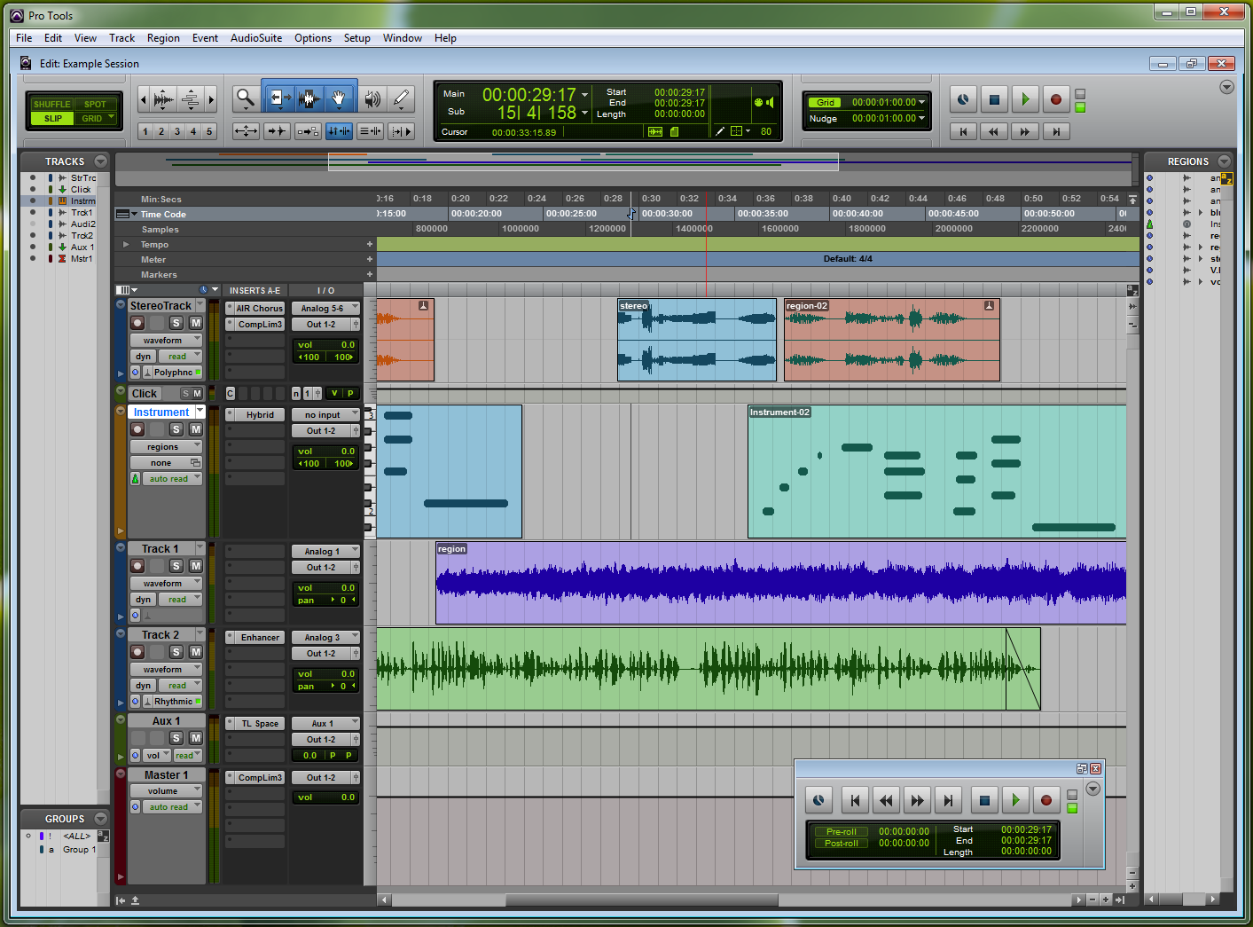
Digital Pro Tools Set up
Audio engineers are built problem solvers. The field itself was invented because there was a problem in communicating and documenting information. From Thomas Edison’s recording cylinder to Evan Brooks inventor of Pro Tools, The main recording system that is used today in all major recording studios audio engineers have worked hard to constantly improve the way they hear and work with audio. Brooks E states "The Pro Tools concept has always been based around the digital audio workstation, combining hardware and software." (http://www.musicradar.com/us/tuition/tech/a-brief-history-of-pro-tools-452963). Reading we learn that the idea of mixing software with the hardware that goes into running a studio is the concept and that these two together have revolutionize the way studios are run. This technical advancement has effected not only the discourse community of audio engineers but also the discourse community of everyone who has a passion for sound, from the person that buys music to the person who creates music. Pro-Tools has stepped up and change the way we create music. Before this concept many recording studios were still limited in what they can produce when is came to sound. This digital audio workstation was a step up in a number of ways. First with a digital audio workstation we had the option of not being limited with the amount of tracks a musician can use to record, prior to that the technology was only up to recording with only 64 tracks. 64 tracks may seem like more then enough but when recording orchestrated music or working on sound for a movie production this advancement was a true gift. The problem with having unlimited tracks is that musician often like to record every idea that pops in the head, not to say that is a terrible thing but often more then not these ideas go nowhere and lead to musicians feeling frustrated due to being overwhelm with unlimited ideas and not having a pin point idea of where to go. The solution for this problem could be to start out with only a limited number of tracks that the artist can work with and built up the idea from there. When finally being satisfied with the idea they can move to the next step that allows them more tracks.
The technology of having a digital audio workstation has made it possible to go from big studios to being able to record at the comfort of your own home. This progression from big studio to home set ups comes with its pros and cons. The home recording set ups have been great for artist and amateur engineers alike, being able to capture inspiration when it hits and work on ideas has saved on time and money but this view isn’t shared by everyone. Because of this technology advancement more major recording centers such as London, Los Angeles, New York, and Nashville are losing the studios that made them famous due to shrinking budgets at the big labels and the growing sophistication of home-recording technology. Now musicians can plug directly into their laptops and record digitally with greater ease than ever. Guarino M, Staff Writer for The Christian Science Monitor comments that “Home Studio Set-ups are tailor-made for cash-strapped musicians and record labels seeking quick and affordable alternatives to the studio model that flourished in the 1970s and ’80s, when lavish recording complexes were built to suit demand.” Well studios are losing money and shutting down the artist are able to have more of a chance in creating the music without worrying about how much the cost maybe or if studio time is available. Possible solutions for both parties would be to come to an agreement on rate. The studios can charge a fee for artist that come with the own equipment or own demos that they wish to bring from the own home recording set ups. This fee would be lower then the cost of people recording only from the studio. This solution is great for the artist because of the affordability to record the music and the studios because they are still making a profit and helping artist at the same time.
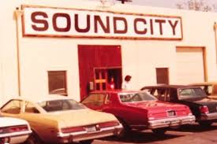
Sound City Recording Studio Los Angeles California
Because of the technological advancement home recording has now become the normal practice of many artists. This practice has produced a lot of armature work by non-skilled audio engineer that has made the quality of the sound become less then satisfactory. Well professional audio engineers learn the science and took the time to master the craft; a majority of non-professional audio engineers have none to little understanding of how the true science of sound works. The way a lot of the home recording systems work is by having a number of presets preselected that audio engineers can use and shape to the desired sound for whatever way they choose. This is not the case with most amateur engineers, for Example without knowing the particular science of why the preset you used to equalize your bass sound works we now have a majority of bass sounds being produce sounding the same. The popularity of home recording has made the sound quality less desirable but because it is what is popular it is passed as acceptable. A solution for this problem could be a number of things from encouraging more costumes to take sound engineering classes to get the full benefit of the product they bought or by having instructional videos with each home recording set up that provides the buyer with at least a little understanding of what the science of audio engineering is. The key in both solutions is emboldening the importance of science.
There are solutions to the many problems plaguing the audio engineering industry but to say these solutions wouldn’t be difficult for the whole discourse community of audio engineers would be a lie. In order to change the way future audio engineers will think we as a whole must change the way we already in the audio engineering discourse community think. The ways that worked in the past are becoming more and more an obsolete method of practice. It is important to remember that as time goes on and technology evolves the industry must evolve as well. We must always be open to new ideas because one great idea can change everything.

References
-Brooks, E. (2011) A Brief History of Pro Tools (http://www.musicradar.com/us/tuition/tect/a-brief-histroy-of-pro-tools-452963.)
-Eargle, J (1996). The Handbook of Recording Engineering. New York : Van Nostrand Reinhold,
- Eargle, J (2007). The Book of Sound Recording. New York : Chapman & Hall
-Emerick, G (2007) Here There And Everywhere. New York : Gotham Books
-Gerard D (2013) Culture Is Not About Aesthetics. Punk Rock Is Now Enforced By Law. http://rocknerd.co.uk/2013/09/13/culture-is-not-about-aesthetics-punk-rock-is-now-enforced-by-law/
-Guarino, M. (2009) Could home recording doom professional music studios?, The Christian Science Monitor, http://www.csmonitor.com/Innovation/2009/1217/Could-home-recording-doom-professional-music-studios
-Guggenheim, D. (Director) & Bender, L. (Producer). (2008). It Might Get Loud (Motion Picture). United States: Paramount Home Entertainment.
- Hecks, D. (2014 )The Pinnacle of Sound Engineering (Interviewed By Salas, R)
-Iyengar, S. (20013) Choosing What To Choose, TED Talk. (http://www.ted.com/talks/sheena_iyengar_choosing_what_to_choose)
-Kenndy, R, (2014) Audio Engineer, Warner Brothers Studio (Interviewed By Salas, R)
-Mix Magizine (May 2005) Preserving The Art Of Audio Engineering. P 4-6
-Olivarez-Giles N, (2009) Recording Studios Are Being Left Out Of The Mix. Los Angeles Times Retrieved from (http://articles.latimes.com/2009/oct/13/business/fi-smallbiz-studios13)
- Porter, J (2012). Intertextuality and the Discourse Community
- Shoemaker T. (2012) Why are female record producers so rare? (Interviewed by Savage Mark BBC news) Retrieved from (http://www.bbc.com/news/entertainment-arts-19284058)
-Thompson, D (2005) Understanding Audio. California : Berklee Press
-Websters encyclopedia 11th edition (2008)

